Foundations of Tourism and Hospitality

Name of the student

Name of the university

Authors note
Executive summary
In recent times it can be considered that, the gathering of knowledge is very much important which plays an important role in the life of the common people. The functionality of the museum is one of the areas, which directly help the people to get the expansion in the knowledge gaining areas so that betterment in life can be made. People tend to gather knowledge, which is related to the different sphere of life, which can even be related to the factor of history and other areas. The art gallery is one of the areas, which takes care of the facts and provides a proper alignment by which the people can easily be indulged into. Moreover, the section of working of the museums are directly linked to the requirement of the customers so that they can exactly get what they require. The framework of working is very much crucial in the sector so that proper working area and gathering of the requirement of the customers is also important which forms the backbone area of working.
Table of Contents
Introduction 4
Visitor’s motivation 4
The dimension of service environment 6
Services capes roles 8
Service quality issue 11
Service guarantees 13
Conclusion 14
References 16

Introduction
In recent times, it can be considered that the factor of the museums is playing an important role in the altering of the society. In an area, it can be considered that an art gallery is a form of education area from were different types of engagement relating to the knowledge gain area can be considered. There are few important factors which can be stated in the context which is related to the manner of working and how the overall gathering of the requirement of the customers are done in the sector of working of the concerned sector. The area of management and the working in the area of the art gallery is very much important which can help in the area of this sustainability factor in the different task, which is done in the area.
The report majorly focuses on two areas, which are the Queensland art gallery and Gallery of modern art. The main concern area of discussion would be prevailing in the sector of the overall working area and how it directly affects the factor of sustainability factor (Whitehead, 2017). The issue in working is also focused and how the mitigation plan can be implemented in the concerned area also taken into consideration. One of the main areas of focus is the reaching of the satisfaction level of the customers so that they would be having an urge to get indulge in the concept of working.

Visitor’s motivation
Queensland art gallery: Queensland Art gallery is considered as Queensland’s premier art visual institute. It is stated as one of the three most visited art galleries; the gallery is directly embraced by different types of audience as an inspiring and inclusive space, which is related to the factor of culture, creativity, and diversity. The main visitors, which prevail in the visit to the gallery mainly, include culture tourist individuals, interstate, international and local people. The gallery’s international program had delivered an economy, which was combined t the benefit of the gallery and the state of more than $100 million.
The motive of visiting: The main motive, which can be stated in visiting the Queensland art gallery, is due to exploring the contemporary area forms from Australia. It is of the centers, which are linked to regions art so that; the visitors can directly indulge in the art and gather different forms of knowledge from the area.
Value: The main area of value gathering can be related to the Queensland art gallery | gallery of modern art is in the learning and children area center, which prevails in the Gallery. The betterment of the knowledge, which is related to the history of Australia, is one of the areas of focus, which is direct delivery in the sector of operation of the gallery.
Gallery of modern art: The gallery of modern art welcomes different forms of tourist from across the world at any time of the year (Perkins & Wilson, 2017). The gallery is majorly housed in a building, which is considered as an iconic building, and it shares with the city central library. Different people visit modern art across the world due to the heritage of the different collections, which are pertained in the library area.
The motive of visiting: The main attraction which is prevailing for the people so that they would be willing to get indulged in the visit is that the library has an internet access terminal and a house of café and the people can directly borrow from a collection art of enticing matter relating to design book and general book.
Value: The main value, which is related to the visit of the gallery of modern area, can be linked to the heritage of the collection and the history, which remains in the book, which is present in the art gallery. In recent times most of the people tend to gather knowledge of the different sections of the working of history so this place can be a huge interest to them (Padilla, 2017). On the other hand, the culture, which is prevailing in the gallery modern art, is important so that the people can directly get a feel of the environment, which can directly add different forms of value in the engagement area.
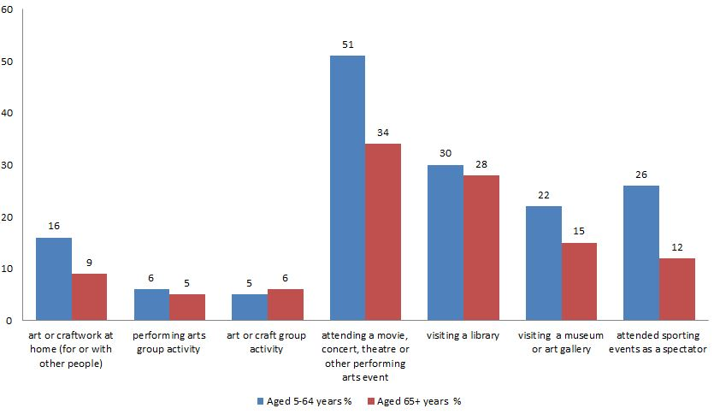
Figure 1: (ENGAGEMENT CRITERIA OF THE PEOPLE)
(Source: Kimura, 2015)

The dimension of service environment
Queensland art gallery: The main service of Queensland is based on the Queensland gallery of modern art, which is known as the GOMA. The original part in the context of operation was designed by Robin Gibson and partners with a focus on delivering of the standard of operation which would be directly dealing with the sector of managing of the need of the people in providing a service environment in which they can directly adopt easily. Due to the service area, which was delivered from the end of the Queensland, art gallery it had received three awards, which were linked to Brisbane commendation, public Architecture award and Queensland chapter of AIA. The main working of the service sector was linked to the driving factor, which directly help in achieving an area of service which would be directly helping the domain of engagement which would be delivering an standard of operation which is linked to the area of gathering of knowledge and the inclusion of the method of achieving of knowledge power. The connection area of the working of the Queensland art gallery and the customers can be considered very much important which can directly reflect the proper area of environment, which can be included in the section of working. The service environment enhancement in the working of the Queensland art gallery can also be enhanced with the different options, which are provided from the end of the patrons who are majorly included in the standard increase of the different services and products.
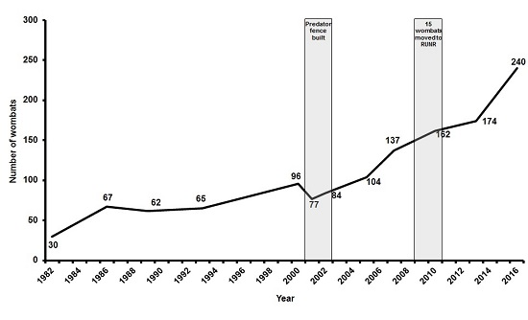
Figure 2: (INCREASE IN ENGAGMENT FACTOR)
(Source: Kimura, 2015)

Gallery of modern art: The main area, which can be related to the factor of the service environment, which is seen in the sector of the gallery of modern art. This mainly prevails in the pavilion in the landscape area so that there are no indulgence problems seen from the end of the people who tend to include themselves in the area of working. In the context, it can be considered that the topology, which is related to the working area, can be considered to be playing an important role in the segment of service environment due to the factor it directly prevails and environment was the different functions could be attained quite easily (Kimura, 2015). The services, which are given to the customers, can be considered important which plays an important role in the context of altering the manner of indulgence and the working area, which is related to the gallery of modern art. In the near future, it can be stated that the gathering of the requirement of the customers is very much important which directly impact the sustainability factor and working of the gallery of modern art. In the area of working there are many concern areas which can be related to the issue and in this area, the issue can arise from different sectors which can hamper the overall service environment. The issues in the context should be mitigated in a proper manner so that there is no problem seen in the context of the indulging area of the patrons.

Services capes roles
Link the main motive, which is prevailing in the working of the service capes can be direct, to the building of n community, which is related to the organizational capability, and partners, which can be used in the sector of delivering of best service to the Queensland. The main working area in the sector can be linked to the strengthening of the gallery national and international reputation, which can be done by means of providing the people accept a service, which would be direct. In the area, alignment of the need of the customers is very much important which directly affects the factor of sustainability. This is one of the major roles which has to be played in the domain due to the factor that if the service and product demand of the customers are not taken into consideration it can directly hamper the internal working of the Queensland art gallery.
Performance indicators
Some of the areas of performance indicators, which can be stated in the sector of working of the Queensland art gallery, are stated below:
- User charges would be directly depending upon the percentage of the total revenue
- The nongovernment charge of revenue would be directly dependent on the percentage of the total revenue.
- The government of Queensland subsidy implementation per visits
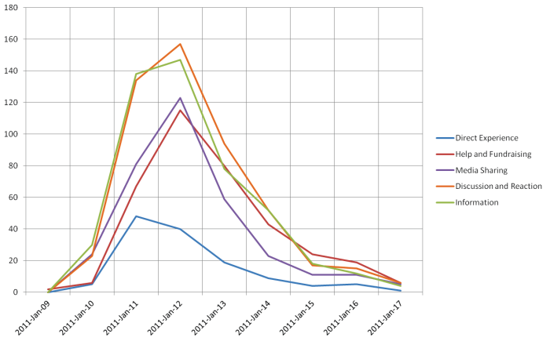
Figure 3: (CHANGE IN DEMAND FACTOR)
(Source: Beattie, 2017)

The above points, which are stated in the context, can be considered roles, which play an important role in the factor of the economic area of working of the Queensland art gallery. Hence, each of the factors holds an important area of justification, which can directly affect the area of service, which is given to the people who want to indulge in working. On the other hand, it can be stated that the sector, which is related to the revenue, which is non-government, can be directly achieved with the role-playing area in the sector of grants, commercial services, and sponsorship (Beattie, 2017). The main role in the section is how the fund, which is achieved, would be used in the sector of the advancement of the service. The concept of planning in the sector can be stated to be one of the most important responsibilities, which can directly affect the overall working of the sector. The area of up liftmen of the service can be considered important segments which play a crucial role in the sector and in most of the cases it can lead to the betterment of the service which can impact the economic and social background of the community.
In the sector of issue creation, it can be stated that the mitigation plan should be implemented in the sector, which is related to the factor of philanthropic support. The sustainability factor, which is related to the factor of the creation of the problem, should be minimized in the working so that it does not hamper the internal working of the Queensland art gallery. On the other hand customers, satisfaction is one of the basic areas, which should be focused in the area so that in the near future the customers would be directly willing to retake the services. It is one of the most crucial areas, which should be focused in the working area which can be linked to the external working of the Queensland art gallery. The future issue managed is another important points, which can be direct to the diverse audience interaction, and communities, which can imports threat relating to the requirement of the service in the sector. The key areas which can be stated here are linked to the factor of increase in the attendance and the significant exits of opportunity to future visitation build area and directly achieve ambitious tourism and sponsorship target in the coming three years including the APT9 in late 2018. Operational efficiency is lacking in the sector of working which is one of the vital Issus which impact the sector of the rise of the prize and subdued economic forecast impede the Gallery’s ability to fund for the concept of continued excellence and innovation.

Service quality issue
In the working of the Queensland art gallery, there are different types of services, which are given from the end of the gallery. Each of the services in the sector is directly designed so that the customers would be given an experience in which they can directly explore the history, which is prevailing in the Australian culture (Kopper, 2016). There are different types of books, which are valuable in the art gallery in which the people can directly learn about the areas of interest, which is prevailing within them. The main aim from the aspect is related to the prohibition of exhibitions and programs to all the Queensland through the gallery regional services. The area of indulgence can also be enhanced with the implementation of the cafeteria in which the people can directly relax in the process of indulging in the knowledge gaining areas (Chandler, 2016). This concept has directly brought different types of people from access the world by which the rate of visitors who are involved in the section of working has increased tremendously.
The main issue in the service quality is related to the authentication of the data, which would be prevailing in the sector. In most of the cases, the data, which is prevailing in the sector, can be stated not to be genuine which can directly impact the visitor interest gaining area. In most of the cases, audits are made in the data so that authenticated data can be directly be provided to the individual who comes into the Queensland art gallery (Gartus, Klemer & Leder, 2015). On the other hand, the Queensland art gallery should be also be taking into consideration the requirement of the individual who tends t visit the art gallery. The concept of a gathering of the requirement can be one of the service issues if the individual is not served with the product and the service, which they wanted to get, indulge in. The critical of engagement with and providing access for the diverse audience and communities is one of the areas of concern due to the very changing need of the people and fluctuating requirement of the people. Hence, the area of manipulation can be considered to be very much important. The services, which are given to the visitors, should be directly being aligned with their requirement so that a standard of operation can be reached quite easily.
One of the factors, which can be stated in the context, is related to the strengthening of the gallery national and international reputation relating to its increase in the collaboration through the partnership of the institutional tourist initiatives. This area can be considered as n concern area due to the increased area of focus for the Queensland art gallery, which can affect the normal area of operation which is related to the working and inducing into the need of the common people. The interest of each of the people who want to get indulged in the working can be considered to be very much important which can directly increase the sustainability factor and mitigate different forms of the issue which are seen in the working area.

Service guarantees
Through the life of the plan which is prevailing in the sector of the gallery, it can be stated that the sector of development can be considered to be a leading ambassador relating to the county of Asia and the Pacific through the basic relationship which is built over more than 20 years of tenure. The gallery in the context of guarantees prevailing is planning to display their 17,000 strong art collection delivering a program, which is related to the factor of excellence through the QAGOMA. The tourism program, which is seen in the sector of the working of the children art center, was one of the services which can directly impact the factor of the running of the services which directly impact the sector of working of the Queensland art gallery.
The gallery program and exhibition area directly encourages the inclusive communities and directly promotes the diverse cultural perspective. The gallery directly gives the services, which is related to the diverse cultural perspective, which is one of the most integrating parts of the services, which are given from the end of the Queensland art gallery. The gallery directly facilities participation by members who prevail from a different background which mainly includes Queenslanders, families and children and the gallery directly focus on the services, which is desired from each of the sectors. Hence, the factor of orientation is one of the important factors, which should be focused in the working area, which directly involves proper alignment in the area of working.
Each of these services which are seen in the sector are aligned with the requirement of the customers, on the other hand, it is mostly seen that the services are proper so that there is no problem seen in the context of dealing with the problem and issue orientation. In the other area, there are many segments of operation, which are taken care of by the Queensland art gallery. The satisfaction level of the people is one of the important factors, which is given one of the optimal areas of concern so that each of the services, which are given in the working of the Queensland art gallery, is optimal (Arya & Chare, 2016). This concept would be directly helping in the sector of engagement of international visitors. Moreover the operational constraint which is seen in the working should be having an proper infrastructure which would be directly helping in the sector of the management of the different activity which are prevailing in the sector.

Conclusion
The report can be concluded on a factor that the art centers are recent times is one of the major backbones, which is related to the context of the educational and knowledge gain area. In this concept, it can be stated that two areas, which are, focused in the report play a significant role, which directly alters the lifestyle of the people and the working of the daily activity. In the near future, it can be considered there would be an extension of the working area and in most of the cases, the people would be gaining different types of benefit from the domain. One of the factors, which should be focused in the domain, is related to the engagement factor of the people and how the people would be indulging into the different concept o working which is prevailing in the domain. More the engagement factor of the people more would be increased in the betterment of the service in the sector.

References
Arya, R., & Chare, N. (Eds.). (2016). Abject visions: Powers of horror in art and visual culture. Oxford University Press.
Beattie, D. (2017). Fairweather: The man and his art. australian art education, 38(1), 185.
Chandler, L. (2016). A Project Waiting to be Done: the legitimisation of contemporary Asian art within the Queensland Art Gallery. Australian and New Zealand Journal of Art, 16(2), 185-201.
Gartus, A., Klemer, N., & Leder, H. (2015). The effects of visual context and individual differences on perception and evaluation of modern art and graffiti art. Acta psychologica, 156, 64-76.
Kimura, T. (2015). A Discourse of Japanese Fashion ‘Discovered’? Future Beauty: 30 Years of Japanese Fashion (Queensland Art Gallery, Gallery of Modern Art, Brisbane, 1 November 2014–15 February 2015). Australian and New Zealand Journal of Art, 15(1), 130-132.
Kopper, P. (2016). America's National Gallery of Art. Princeton University Press.
Mulholland, N. (2017). The cultural devolution: art in Britain in the late twentieth century. Routledge.
Padilla, S. M. (2017). The Coffee House Art Gallery: An" Alternative" to the Alternative Art Space (Doctoral dissertation).
Pergam, E. (2017). The Manchester art treasures exhibition of 1857: entrepreneurs, connoisseurs and the public. Routledge.
Perkins, M., & Wilson, A. (2017, January). Red green blue: A history of Australian video art. In Red Green Blue: A History of Australian Video Art. Queensland College of Art, Griffith University Gallery.
Szulakowska, U. (2017). Alchemy in contemporary art. Routledge.
Walsh, T. (2018). Patricia Piccinini: Brisbane: Queensland art gallery| gallery of modern art-curious affection. ArtAsiaPacific, (109), 100.
Walsh, T. R. (2019). The 9th Asia Pacific Triennial of contemporary art. ArtAsiaPacific, (112), 130.
Walton, A. (2019). The Imagined Memorial Gallery: Britain’s Aspiration to Commemorate the Great War Through Art. In The Palgrave Handbook of Artistic and Cultural Responses to War since 1914 (pp. 391-406). Palgrave Macmillan, Cham.
Whitehead, C. (2017). The public art museum in nineteenth century Britain: the development of the National Gallery. Routledge.

