Digital Technologies

Design Brief
The designing of an online game involves forming a multi disciplinary team and working in collaboration in order to complete the project successfully. It is crucial to ensure that there be effective understanding of how the project is to be managed. The challenge undertaken was to design a game that uses controllers and executing as well as testing the game codes. The various roles involved were game designer, programmer, engineer and project manager.
Context and challenge undertaken
My role in this challenge of designing a game was of the project manager and my main responsibilities included checking if the design was appropriate or not and to ensure that all resources were well managed and used optimally for the project. These elements were extremely crucial in order to complete the firm successfully and on time.
The first activity that I was actively involved in after the group discussions include producing a project plan. The curriculum area chosen is designing a game where controllers are to be used. In the curriculum it is for year 5 level work. Several other work samples were identified and considered for forming a framework to build the game from scratch.
Specifications
The biggest challenge was in designing the game and its stages. It required extensive brain storming in order to understand the theme of the game. We finalized on a racing game which involved different cars and vehicles. Controllers would be used to play this game and the code had to be formed for each of the stages of the game. Integration of all of these codes was done at the last stage.
Generating the design
Another challenge that we faced was to co ordinate all the programmers to first understand the concept and stages and then form the codes accordingly. Since all codes were to finally be merged, it made it extremely challenging to write codes for different stages of the game.
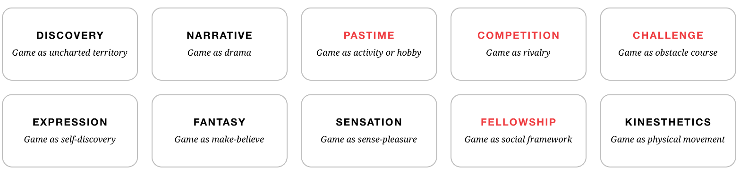
The design was built based on various frameworks viewed from the gaming domain. A model of game designing based on creativity and innovation as well as ensuring better understanding about the game design process. It involved various aspects including forming the concept, the narrative, pastime and competition or challenges. It also involves expressions, fantasy and sensation along with fellowship and kinesthetic all of which are an essential part of forming the fame design.
It is required that there be appropriate evaluation of how the design of the game can help build in several features that support the game and also enable the creation of an appropriate level of understanding about how the functioning of the game can be enhanced. In this way designing the game was the biggest challenge in the course which required usage of knowledge from multiple domains.
Producing and implementing
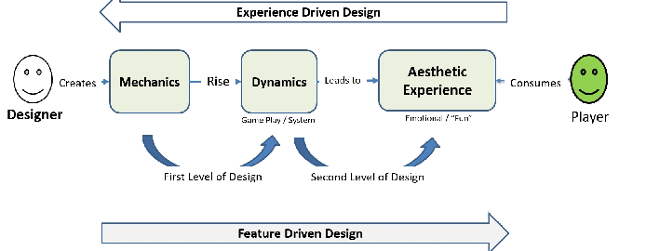
It was crucial that the design be tested multiple number of times so that the issues and glitches could be taken care of. It was required that there be a detailed understanding of how the game would function and what was its target audience. At the same time it is required that there be an appropriate understanding of how the game can be made the most entertaining without any technical glitches. It required the team to focus on building a great experience for the user.
Collaboration and managing
Collaboration of the team was a very difficult aspect as it involved the consideration of using multiple elements ranging from skills and resources to helping each of the members co ordinate. It was essential to bring about a detailed level of understanding about the designing objectives so that there was no confusion in the process. At the same time, it was required that there be understanding about how the process was to be enhanced through synergies. It required an understanding about the creation of a team objective and plan to achieve the objective. Each of the members were assigned specific responsibilities and then provided with a time framework in order to complete the same. In this way collaboration became possible.
Evaluation
The evaluation of the project was a very difficult aspect as checking the game design could be made possible only by testing it online by using multiple software. This required installations of software and several technical aspects of game design. It was done based on research and on understanding how other frameworks were designed for evaluation process This helped focus on delivering accuracy in the design and ensuring that any errors were taken care of in the initial stages itself. In this way the evaluation of the game design was completed.
Two sets of principles to support these approaches
The first principle to support these approaches is that practical learning can help students learn as well as gain confidence. It helps learn not only the concepts and theories but also several life skills including working in teams, listening to other ideas and experimenting or taking risks. These elements help us grow as well as support us in the long run. It was quite challenging for us to be able to design a new game from a scratch with so many ideas brimming within the group. Towards the end, we worked with great levels of co ordination and brought in sufficient understanding to complete the project successfully.
The second principle that we used to support the approach of identifying similar projects and collecting samples was of great help. It helped us gain direction as to how we wanted to design our project and what software or code writing techniques we would prefer. At the same time, it helped us save a lot of time as we did not have to brainstorm on trivial matters. It also helped us know how advance gaming can be and that it actually requires a lot of hard work and skills to be able to design a game. The focus was on creating a stronger level of understanding of the concept and building a better level of expertise in the domain of game design and creation so that it helped us write the game codes appropriately.

